This document expands on the Tabard Rugby Football Club Constitution (Rules of the Club)

Equity Policy Statement

Tabard RFC recognises the importance of affording equity, equal opportunity and fair treatment to all present and potential employees and members.

Equity Policy Objectives

The Tabard RFC Equity Policy has the following objectives:

- We aim to ensure that all people, irrespective of their age, gender, race, religion, ethnic origin, creed, colour, nationality, social status or sexual orientation, have a genuine and equal opportunity to participate in rugby union at all levels and in all roles. This includes participation as a beginner or elite performer, as a coach, official, referee, manager, administrator, Director or spectator.

- In our relationship with members, employees and, in our provision of services, it is the aim that we, Tabard Rugby Club, do not disadvantage any individual by imposing any conditions or requirements which cannot be justified.

- To adopt a planned approach to eliminate perceived barriers which either cause direct discrimination or indirect discrimination. Direct discrimination is defined as treating a person less favourably than others in the same or similar circumstances. Indirect discrimination occurs when a requirement or condition that is applied, whether intentional or not, adversely affects a considerably larger proportion of people.

- We will ensure that all those who volunteer or work for the club will receive fair and equitable treatment.

NB. Tabard RFC reserves the right to limit competitions to persons of specific age, gender or disability where this is necessary to ensure equitable, safe and equal competition.

Tabard RFC reserve the right to discipline any of its members or employees who practice any form of discrimination as noted above.

Where younger members are concerned, Tabard RFC will be especially vigilant, as outlined in the separate Club Safeguarding Policy.
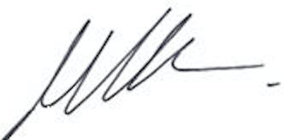

Mark Richardson
19th May 2026
(To be reviewed on 19th May 2027)

